Exp. 7. MOSFET Scaling Analysis and Subthreshold Swing Calculation using NanoHub
Aim: To study the current-voltage characteristics and transconductance efficiency of a single-gate MOSFET using the NanoHUB FetToy Simulator.
Output:
Case 1: Increase in VG : ● Observation: As VG increases, the drain current (ID ) also increases exponentially due to the MOSFET entering the saturation region earlier. 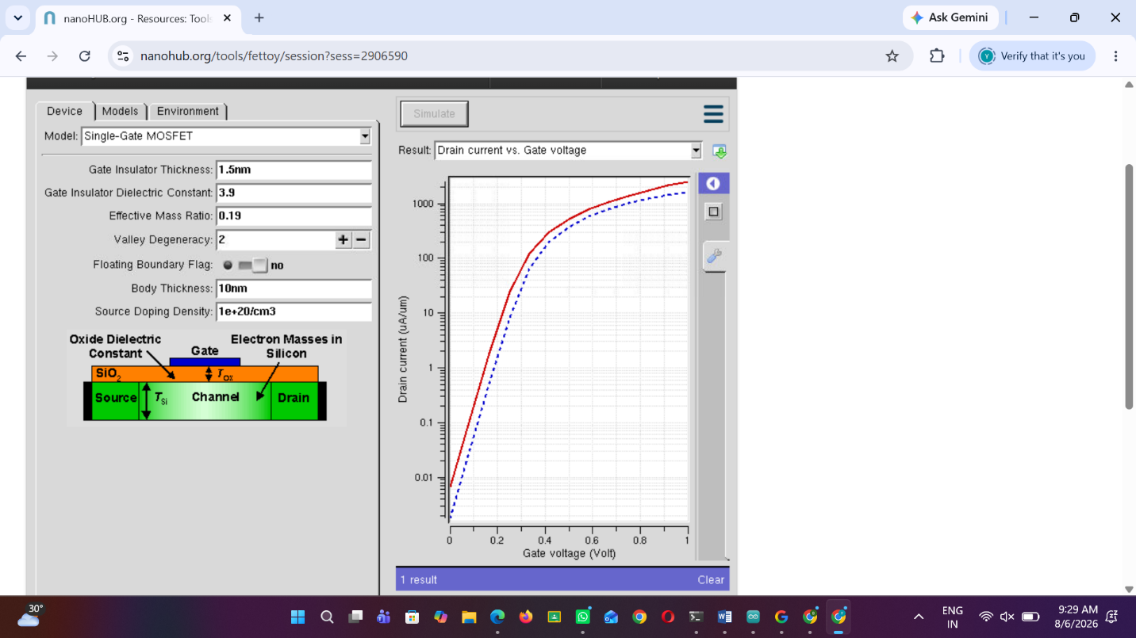
Case 2: Variation in VD : ● Observation: Drain current (ID ) saturates for higher VD at
